NETWORKING CAPSTONE PROJECT

Prepared by: Raphael Ndidi-Uboma
Student ID: GRC-C26-09-NA-014
Date: September 30, 2026

COMPLETED NETWORK TOPOLOGY
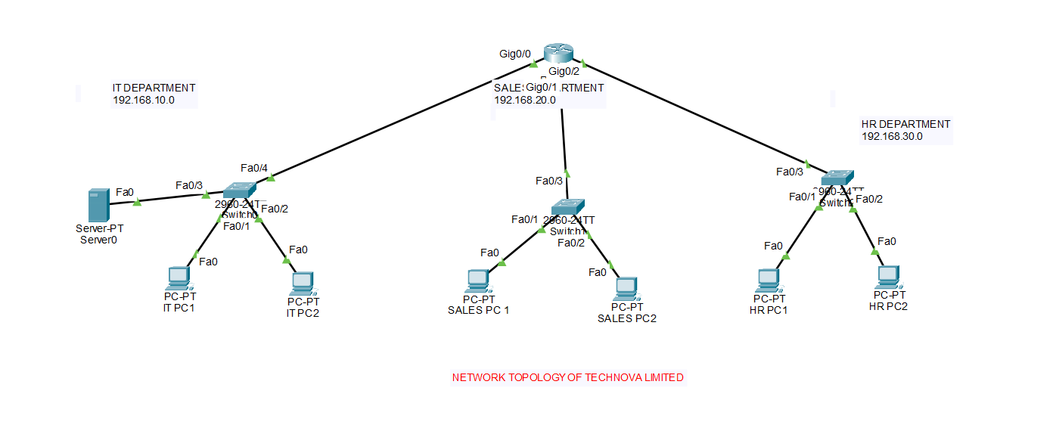

This network topology was created in Cisco Packet Tracer by placing one Cisco 2911 router, three Cisco 2960 switches, one server and six PCs. Each department was connected to its own switch, and each switch was connected to a separate router interface using straight-through cables. The IT switch also connects the IT server and two IT PCs.

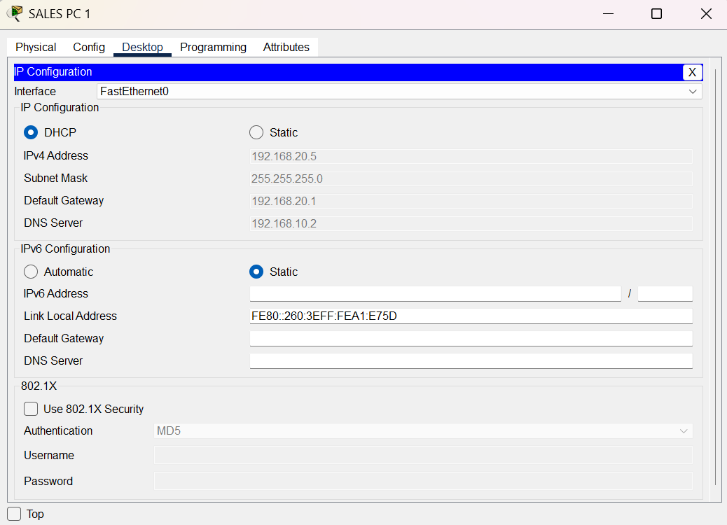
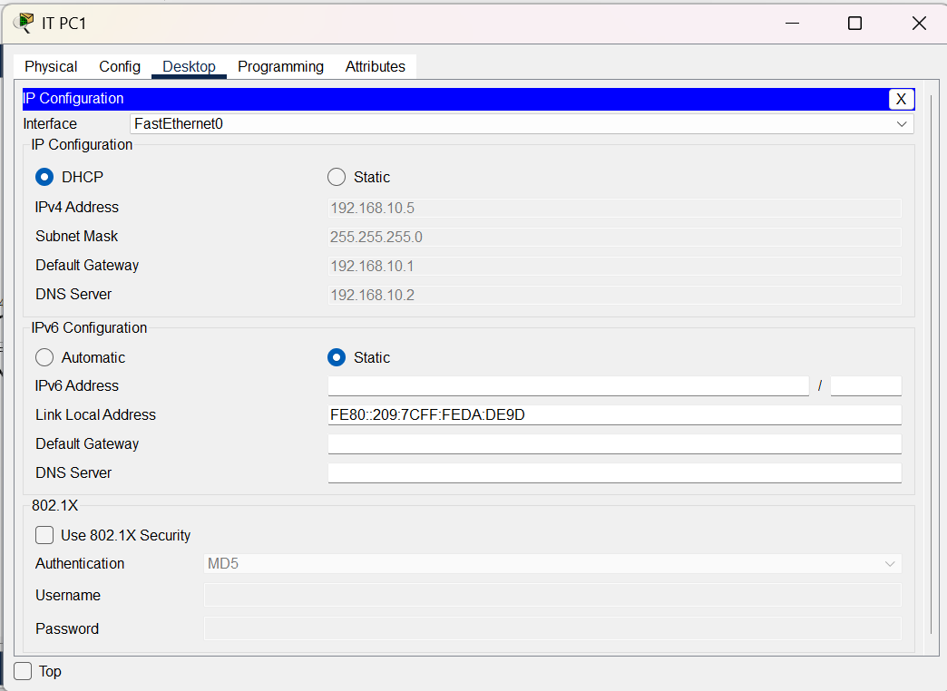
IP ADDRESS CONFIGURATION ON AT LEAST 1 PC IN EACH OF THE 3 DEPARTMENTS

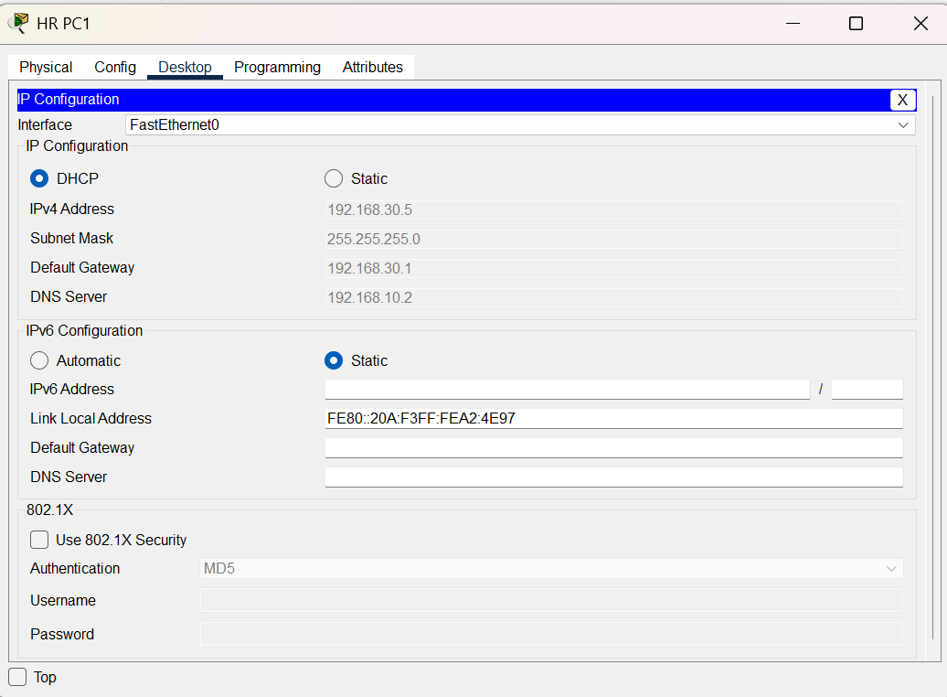

The PCs were configured to obtain their IP addresses automatically using DHCP from the router. IT department uses 192.168.10.0/24, Sales uses 192.168.20.0/24, and HR uses 192.168.30.0/24. The router provides the default gateway for each departmental network. The screenshot confirms that at least one PC in each department received an address from the correct subnet.

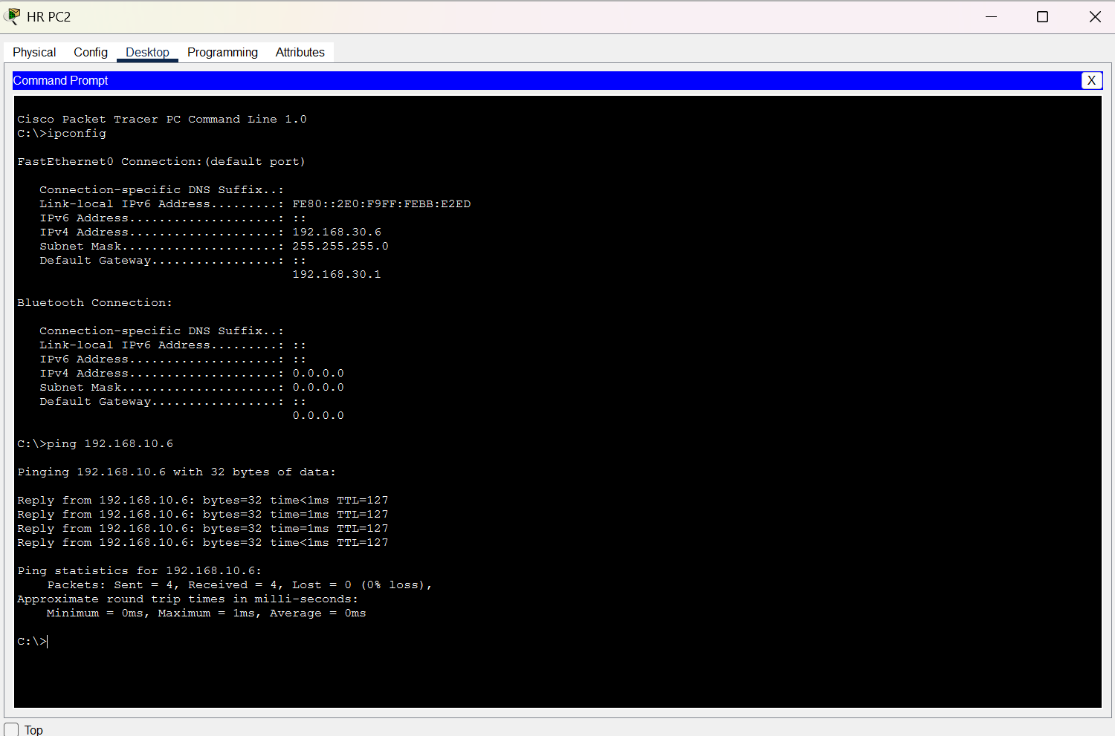
SUCCESSFUL PING FROM A HR PC TO AN IT PC

A ping was sent from an HR PC to an IT PC. The successful replies verified that the router was correctly routing traffic between the HR and IT networks and that the IP addressing and connectivity were working correctly.
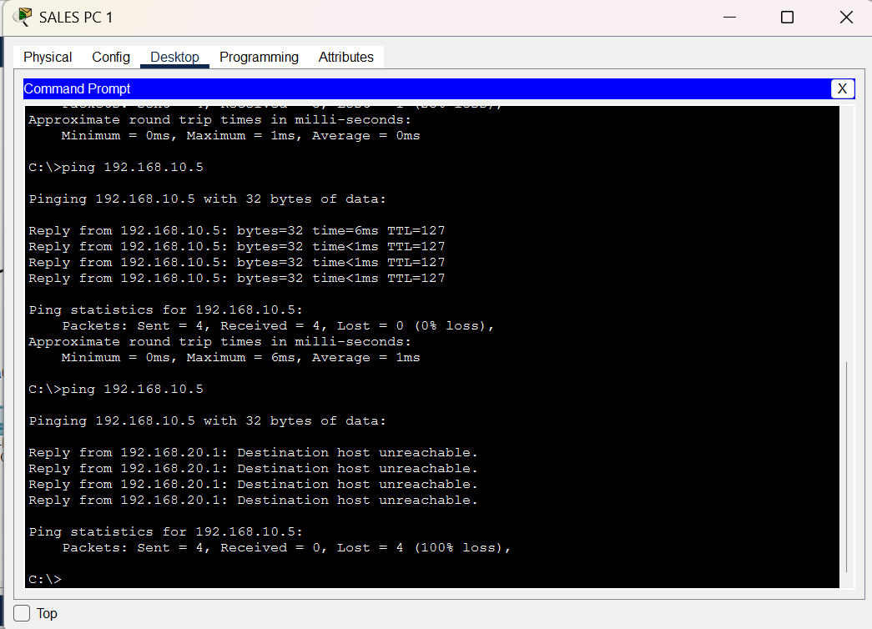
FAILED PING FROM A SALES PC TO AN IT PC

An extended ACL was configured on the router to deny ICMP traffic from the Sales network, 192.168.20.0/24, to the IT network, 192.168.10.0/24. The failed ping confirms that the required Sales-to-IT ICMP restriction was successfully applied.

ACL CONFIGURATION
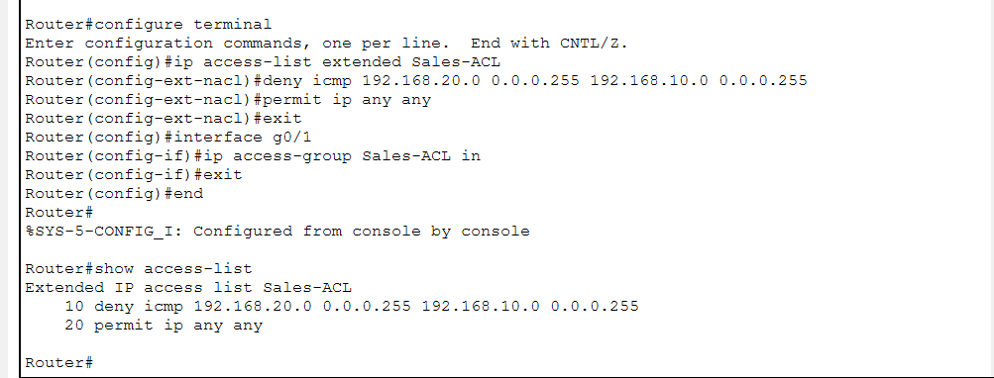
The ACL was entered through the router CLI. It denies ICMP traffic from Sales to IT while permitting other IP traffic. This allows required services such as HTTP and FTP to remain available while the specified ping traffic is restricted. The ACL was applied to the Sales-facing router interface in the inbound direction.

SALES ACCESS TO HTTP SERVICE
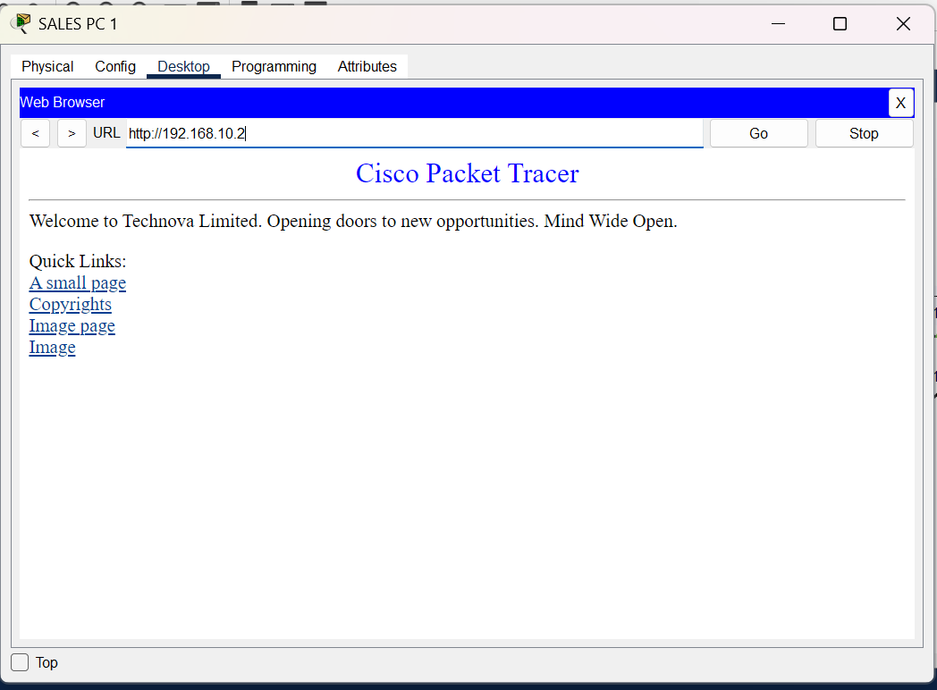
A Sales PC accessed the HTTP service hosted on the IT server at 192.168.10.2. The successful web access demonstrates that the ACL restricts the specified ICMP traffic without preventing Sales from using the server's HTTP service.

